吴老师，骆学长和孙学长好，以下是我的作业。

–教材
P.186 题 15：链表实现集合运算。要求：不使用辅助表元，实现功能函数1. void unionSet(struct List *s1, struct List *s2, struct List *result); 2. void differenceSet(struct List *s1, struct List *s2, struct List *result); 3. void intersectionSet(struct List *s1, struct List *s2, struct List *result)。测试要求：S1 = {2, 3, 5, 6}，S2 = {3, 4, 6, 8}。
– 上机指导书
实验七 6思考题：理论题。
– 补充题：
创建链表，链表中的结点值依次为“10 20 30 40 50”，Delete 函数用于删除链表中所有值大于 min 且小于 max 的结点(表元)，同时释放被删结点空间。如设定 min=10 和 max=35，Delete 函数将使得链表中结点值被删为"10 40 50“。

Chi-Shan0707/Homework-in-CS10004-Programming-by-yhchi
代码仓库↑

T1.
核心思想：不断比较，不厌其烦地比较

#include <stdio.h>
#include <stdlib.h>

// 单向链表节点
struct Node
{
int val;
struct Node* next;
};
typedef struct Node Node;
struct List
{
Node* lsthead;
};
typedef struct List List;
void convert(List* lst, int arr[], int n)
{
lst->lsthead = NULL;
if (n <= 0) return;
Node *head = ( Node *) malloc ( sizeof (Node) ) ;
head->val = arr[0];
head->next = NULL;
lst->lsthead = head;
Node* tail = head;
for (int i = 1; i < n; ++i)
{
Node* cur = (Node*)malloc(sizeof(Node));
cur->val = arr[i];
cur->next = NULL;
tail->next = cur;
tail = cur;
}
}
void free_list(List* lst)
{
//记得整体清空

Node* head = lst->lsthead;
while(head)
{
Node *tmp = head;
head = head->next;
free(tmp);
}
lst->lsthead = NULL;
//记得置空
}
void print_list(const char* name, List* lst)
{
printf("set %s = {", name);
Node* head = lst->lsthead;
int is_firstitem = 1;
while (head)
{
if (!is_firstitem) printf(" , ");
printf("%d", head->val);
is_firstitem = 0;
head = head -> next;
}
printf("}\n");
}
void append(List *lst, Node **tail_ptr,int val)
{
Node* new_node = (Node*)malloc(sizeof(Node));
new_node->val = val;
new_node->next = NULL;
if (lst->lsthead == NULL)
{
lst->lsthead=new_node;
}
else
{
(*tail_ptr)->next=new_node;
}
*tail_ptr = new_node;
}
// 2. 差集 S1 \ S2
void differenceSet(struct List *s1, struct List *s2, struct List *res) {

Node* head1 = s1->lsthead;
Node* head2 = s2->lsthead;
Node* tail = NULL;
free_list(res);
res->lsthead = NULL;
while(head1!=NULL)
{
int exist_in_s2=0;
for(head2=s2->lsthead; head2!=NULL; head2=head2->next)
{
if(head2->val==head1->val)
{
exist_in_s2=1;
break;
}
}
if(!exist_in_s2)append(res, &tail, head1->val);
head1=head1->next;
}

}
void intersectionSet(struct List *s1, struct List *s2, struct List *res)
{
Node* head1 = s1->lsthead;
Node* head2 = s2->lsthead;
Node* tail = NULL;
free_list(res);
res->lsthead = NULL;
while(head1!=NULL)
{
int exist_in_both=0;
for(head2=s2->lsthead; head2!=NULL; head2=head2->next)
{
if(head2->val==head1->val)
{
exist_in_both=1;
break;
}
}
if(exist_in_both)append(res, &tail, head1->val);
head1=head1->next;
}
}

void unionSet(struct List *s1, struct List *s2, struct List *res)
{
Node* head1 = s1->lsthead;
Node* head2 = s2->lsthead;
Node* tail = NULL;
free_list(res);
res->lsthead = NULL;
head2=s2->lsthead;
while(head2!=NULL)
{
append(res, &tail, head2->val);
head2=head2->next;
}
head2=s2->lsthead;

while(head1!=NULL)
{
int exist_in_s2=0;
for(head2=s2->lsthead; head2!=NULL; head2=head2->next)
{
if(head2->val==head1->val)
{
exist_in_s2=1;
break;
}
}
if(!exist_in_s2)append(res, &tail, head1->val);
head1=head1->next;
}

}

int main() {
List S1, S2, U, D, I;
int a1[] = {2, 3, 5, 6};
int a2[] = {3, 4, 6, 8};
convert(&S1, a1, sizeof(a1)/sizeof(a1[0]));
convert(&S2, a2, sizeof(a2)/sizeof(a2[0]));
U.lsthead = D.lsthead = I.lsthead = NULL;

print_list("S1", &S1);
print_list("S2", &S2);

unionSet(&S1, &S2, &U);
print_list("S1∪S2", &U);

differenceSet(&S1, &S2, &D);
print_list("S1\\S2", &D);

intersectionSet(&S1, &S2, &I);
print_list("S1∩S2", &I);

// 释放
free_list(&S1);
free_list(&S2);
free_list(&U);
free_list(&D);
free_list(&I);
return 0;
}

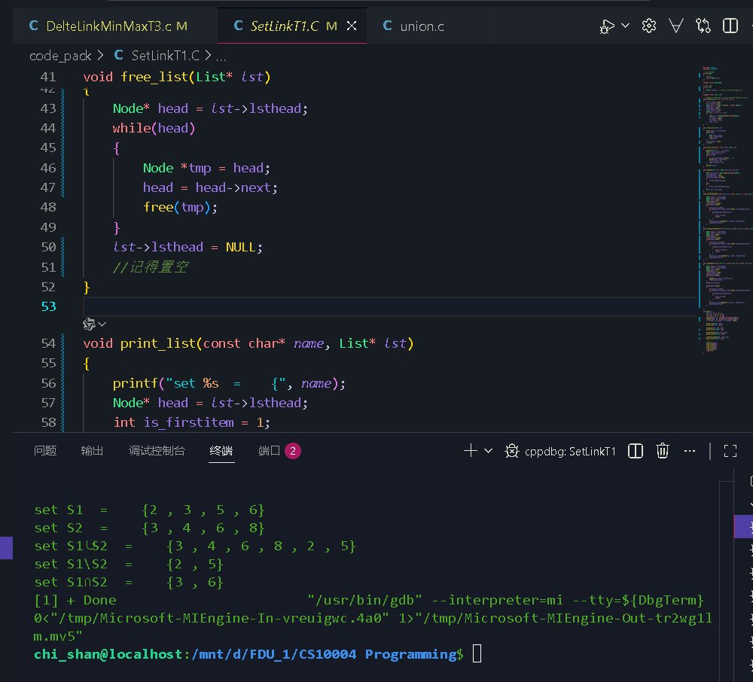
T2
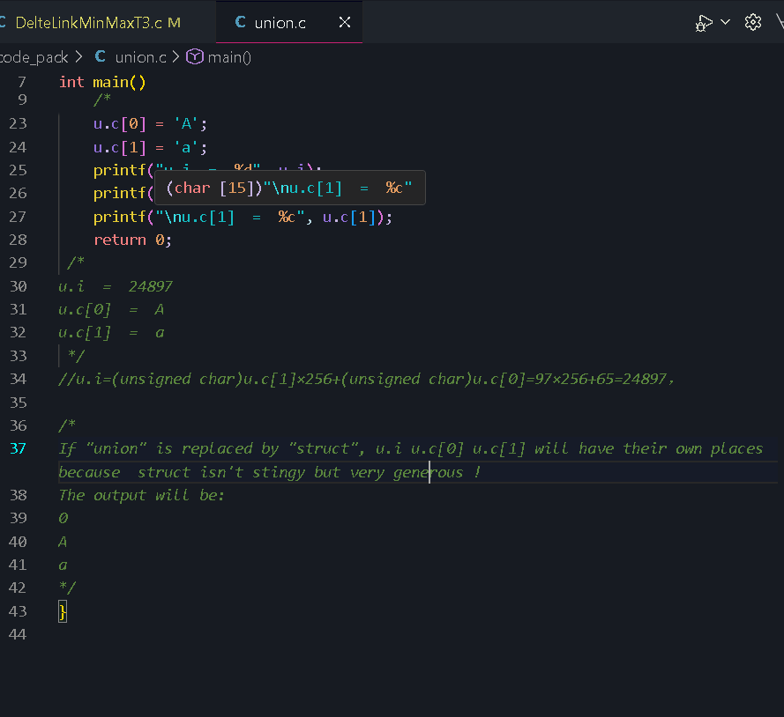

T3

#include <stdio.h>
#include <stdlib.h>
struct Node
{
int val;
struct Node* next;
};
typedef struct Node Node;
Node* convert(int arr[], int n)
{
int i;
Node* head = (Node*)malloc(sizeof(Node));
Node *tail=head;
if(n == 0)return NULL;
head->val = arr[0];
head->next = NULL;
for(i=1;i<n;++i)
{
Node* cur = (Node*)malloc(sizeof(Node));
cur->val = arr[i];
cur->next = NULL;
tail->next = cur;
tail = cur;
}
return head;
}
void print_list(const char* name, Node* head)
{
printf(" List %s = { ", name);
int is_firstitem = 1;
while (head)
{
if (!is_firstitem) printf(" -> ");
printf("%d", head->val);
is_firstitem = 0;
head = head -> next;
}
printf(" }\n");
}
void free_list(Node* head) {
while (head)
{
Node* tmp = head;
head = head->next;
free(tmp);
}
}
// Delete: 删除值大于 min 且小于 max 的结点，同时释放空间
void Delete(Node** head_ptr, int min, int max) {
if (head_ptr == NULL) return;
Node* cur = *head_ptr;
Node* prev = NULL;
while (cur) {
if (cur->val > min && cur->val < max) {
Node* to_del=cur;
if (prev == NULL) {
// 删除头结点,比较麻烦
*head_ptr=cur->next;//将问题留给下一个人
cur = *head_ptr;
}
else
{
prev->next=cur->next;
cur = prev->next;
}
free(to_del);
}
else
{
prev=cur;
cur=cur->next;
}
}
}

int main(void) {
int arr[] = {10, 20, 30, 40, 50};
Node* head = convert(arr, sizeof(arr)/sizeof(arr[0]));

/*
创建链表，链表中的结点值依次为“10 20 30 40 50”，Delete 函数用于删除链表中所有值大于 min 且小于 max 的结点(表元)，同时释放被删结点空间。如设定 min=10 和 max=35，Delete 函数将使得链表中结点值被删为"10 40 50“。
*/
int min = 10, max = 35;
print_list("Before operation(min=10, max=35)", head);
Delete(&head, min, max);

print_list("After operation(min=10, max=35)", head);

free_list(head);
return 0;
}

